Academic Year -: 2026-27
Date: 11-07-2026


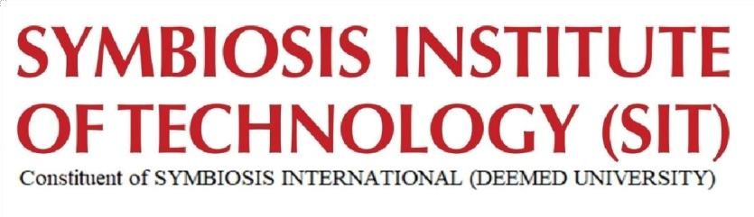

B-Tech Project

ForgeFlow: An AI-Native End-to-End Software Development
Lifecycle Automation Platform

Under the guidance of
Dr. Payal Kadam

Group Number | 4
Name | PRN | CLASS
Faheemuddin Sayyed | 23070122196 | CSE - C
Sanidhya Awasthi | 23070122192 | CSE - C
Raghav Sonchhatra | 23070122172 | CSE - C

PROBLEM STATEMENT

ForgeFlow - an AI-native, human-in-the-loop web platform that carries a product idea from screenshots or a structured spec through automated UI design, full-stack code generation, requirement-driven testing with self-healing repair, and one-click cloud deployment, while letting the user refine, revisit, or skip any stage at will.

ABSTRACT
Modern AI application builders such as Lovable, Bolt, and Replit Agent have collapsed the distance between an idea and a running web application, yet they share three weaknesses: code generation is loosely verified, so users are frequently trapped in unbounded bug-fixing loops; testing of the live, deployed application is rarely a first-class step; and deployment either locks users into a single proprietary cloud or exposes them to infrastructure configuration that non-experts cannot navigate. ForgeFlow is an AI-native, human-in-the-loop platform that automates the full software development lifecycle for web applications while keeping the developer in control at every stage.
Delivered as a Progressive Web App with an embedded browser IDE, the platform accepts an idea expressed as screenshots, a natural-language description, or the user's own designs, and moves it through five orchestrated stages. First, design: reference images or prompts are converted into high-fidelity UI through a pluggable provider (Google Stitch over the Model Context Protocol, with Figma as an alternative). Second, generation of a fixed, reliable stack - React frontend, Node/Express backend, and MongoDB - driven by an agentic loop over a large language model, with code streamed live to the IDE. Third, verification: a structured, fill-in-the-blanks requirements guide is compiled into executable unit and end-to-end (Playwright) tests. Fourth, infrastructure-aware deployment, offering either seamless provisioning on platform-managed accounts (Vercel and Render) or the user's own credentials, rendered as a live component topology. Fifth, validation of the deployed site against the same tests.
The core contribution is a bounded, diff-aware self-healing loop: when tests fail, only the failing output and the relevant code diff are returned to the agent for targeted repair, governed by retry caps and no-progress detection that escalate to the human rather than looping indefinitely. Crucially, no stage is mandatory - users can refine any output conversationally, re-enter earlier stages, or opt out entirely, making the pipeline fully non-linear. Each project is provisioned an isolated database with a built-in CRUD data browser.
The system is evaluated on a benchmark of representative application specifications, measuring first-pass and post-repair test success, repair-iteration counts, and end-to-end time from screenshot to deployed URL - demonstrating that disciplined verification and flexible human control can coexist with fully automated build-and-deploy.

Outcomes
- A deployed PWA where a user goes from a few reference screenshots to a live, hosted website URL end to end.
- Image/prompt → high-fidelity UI generation through a pluggable design layer (Stitch MCP default, Figma MCP alternative).
- Agentic full-stack generation on a fixed stack (React + Node/Express + MongoDB) with code streamed live into an in-browser Monaco IDE.
- Isolated, per-project execution sandbox with live preview of the running app.
- A structured, fill-in-the-blanks requirements capture that compiles directly into unit and Playwright E2E test suites.
- A bounded, diff-aware self-healing repair loop with retry caps, no-progress detection, and human escalation - the project's central technical contribution.
- Cloud-infra analysis that classifies each project's needs and recommends the simplest viable deployment target.
- Dual-mode deployment: seamless on platform-managed accounts, or bring-your-own tokens/credentials.
- Post-deployment validation that re-runs E2E/smoke tests against the live URL and repairs on failure.
- An n8n-style visual deployment topology showing FE/BE/DB components with live status.
- Per-project database isolation plus a project-scoped CRUD data browser; optional user-supplied MongoDB URI.
- Fully non-linear orchestration: every stage is optional, conversationally refinable, and re-enterable.
- An evaluation harness reporting first-pass vs post-repair test success, repair-iteration counts, and screenshot-to-URL time - the basis for a paper or a hackathon pitch.

User Flow Diagram
